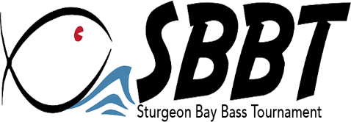

Sturgeon Bay Bass Tournament Sponsor Levels

Title Sponsor: $3,000.00
- All promotions listed in lower levels, PLUS…
- SBBT “Presented By” your business logo
- Four spaces of display area at tournament site
- Multiple banner spaces
- Consistent sponsor mentions throughout the tournament
- Linked logo to tournament website
- Multiple mentions on tournament Facebook page
- Primary placement on newspaper advertisements

Major Sponsor: $2,000.00
- Two spaces of display area at tournament site
- Two banner spaces
- Multiple sponsor mentions throughout the tournament
- Linked logo on tournament website
- Mentions on tournament Facebook page
- Large logo in newspaper advertisements

Elite Sponsor: $1,000.00
- One space of display area at tournament site
- One banner space
- Sponsor mention at welcome and at awards
- Logo on tournament website
- Mentions on tournament Facebook Page
- Logo in newspaper advertisements

Supporting Sponsor: $500.00
- Logo on tournament website
- Mentions on tournament Facebook page
- Sponsor mention at awards

Continuing Sponsor: $250.00
- Mentions on tournament Facebook page
- Sponsor mention at awards

