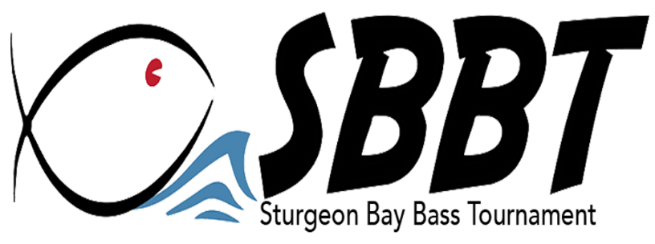
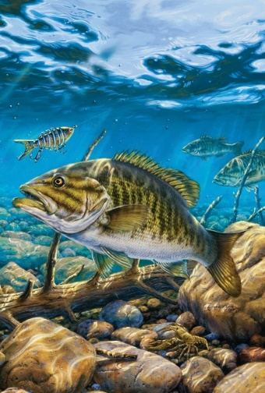

The Sturgeon Bay Bass Tournament will lead off the 2024 Door County bass tournament season by holding our event on Thursday, May 2nd and Friday, May 3rd at Sawyer Park in Sturgeon Bay. We would be honored to have your business as a sponsor for our 2024 tournament.

Enclosed is a sponsorship sheet for your review. We welcome any special requests and ideas that would tailor to your business. Please allow our tournament to grow with your sponsorship. Feel free to contact us with any special promotion to benefit your business and help our sponsorship work for you!

As a locally run bass tournament, we pride ourselves on how we protect the long-term sustainability of the bass fisheries of Sturgeon Bay/Door County for future anglers. We continue to be the only Door County tournament to use the “Weigh on The Water” format – a format that has been adopted by several national bass tournament circuits and an increasing number of WI DNR permitted tournaments. This format requires teams to take a short video of the weight and live release of the bass they register. After registering their fish using an app on their cell phone, the fish are returned right where they were caught and eliminates any negative effects that occur from handling, displacement, and disease when fish are brought back to the boat ramp for weigh-in on shore.

The majority of our anglers frequent our local businesses during their 2–3-week pre-fishing trips, during the tournament, and return after the tournaments to further enjoy our great fishing. Through our advertising campaign including our Facebook page and website, radio, and Let’s Go Door County (and their 15,000+ subscribers), your business will be introduced to all our anglers and more.

We look forward to your response and appreciate you! Please contact Gary Nault at 920-495-6551 with any questions.
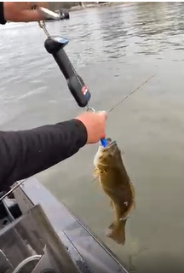
Sincerely,

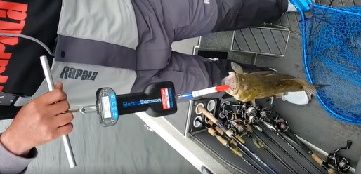
Gary Nault – Tournament Director

SBBT Staff: Chum & Linda Nault, Tom & Cheryl Berke,
Rick Wiesner, Mark & Michaela Holey

Please send your check to SBBT
711 Hickory St
Sturgeon Bay , Wi 54235

“Always Remembering Cheryl Nault”

